***Enhancing Cybersecurity: User Management, Access Control, and System Protection in Windows***

**1. Create a new user named "TestUser" with the password "TestPassword123" and assign limited rights:**

To begin, I opened **Start**, then navigated to **Control Panel**. From there, I accessed **User Accounts**, where I successfully created the user **"TestUser"**, setting the password as **"TestPassword123"**

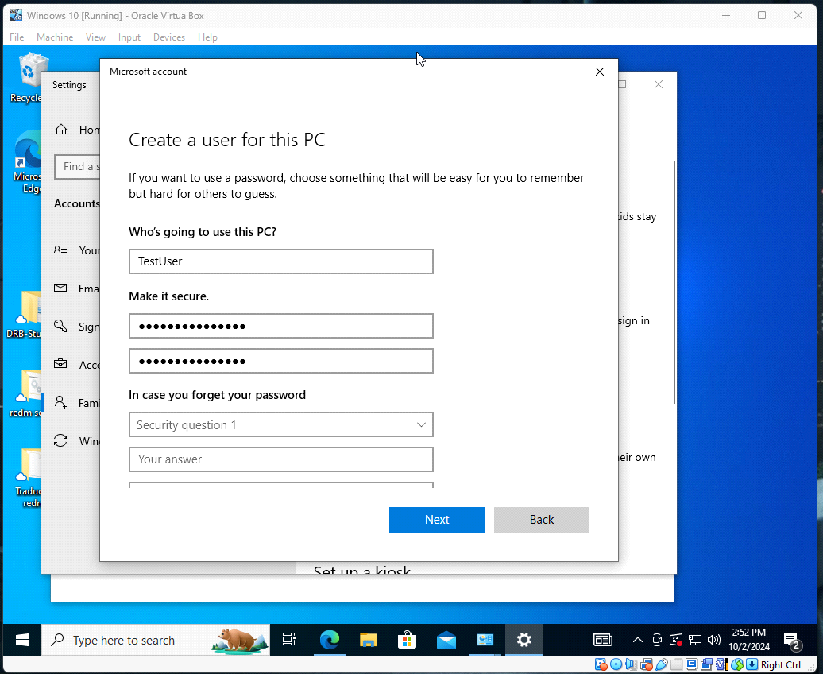

**2. Create a folder named "TestFolder" on the desktop. Grant read-only access to the previously created user "TestUser":**

To begin, I right-clicked on the desktop and selected the **New** option to create a new folder, naming it **"TestFolder"**. After creating the folder, I right-clicked on it and selected **Properties > Security**, where I granted **read-only** access to the user.

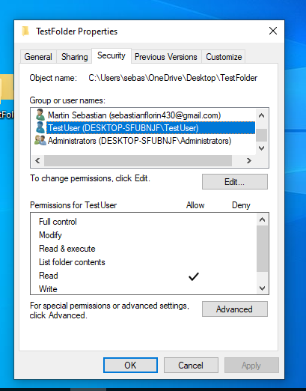

**3. Modify login settings: Enable event logging for failed login attempts. Check the logs to confirm that logging has been successfully activated:**

To begin, I accessed **Start**, then opened **Event Viewer**, followed by **Windows Logs > Security**. In the right panel, I clicked **Filter Current Log**, and in the window that appeared, I selected **Failure** and clicked **OK**. To verify that logging has been activated, I went to the **Security** section and searched for events with **ID 4625**

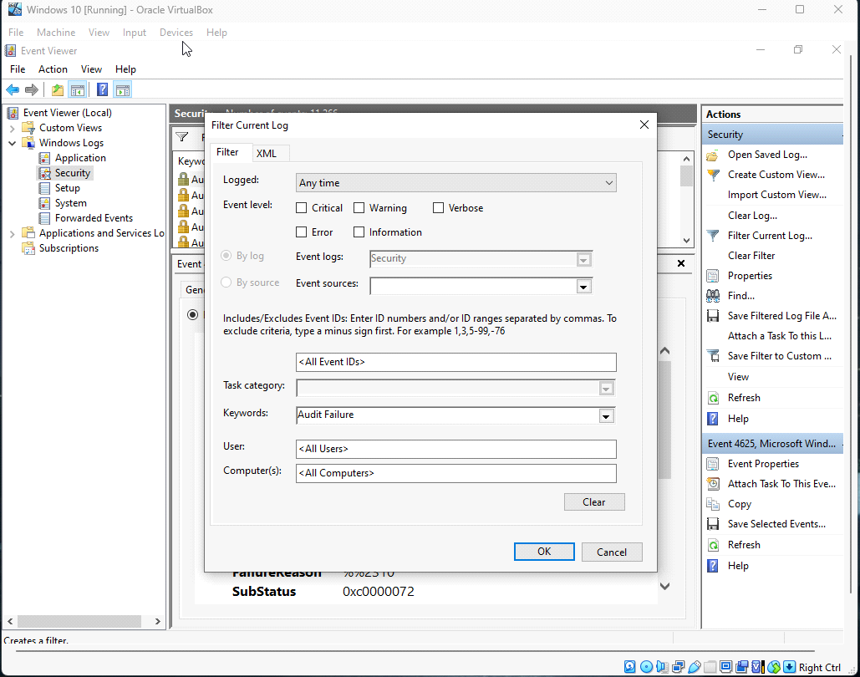

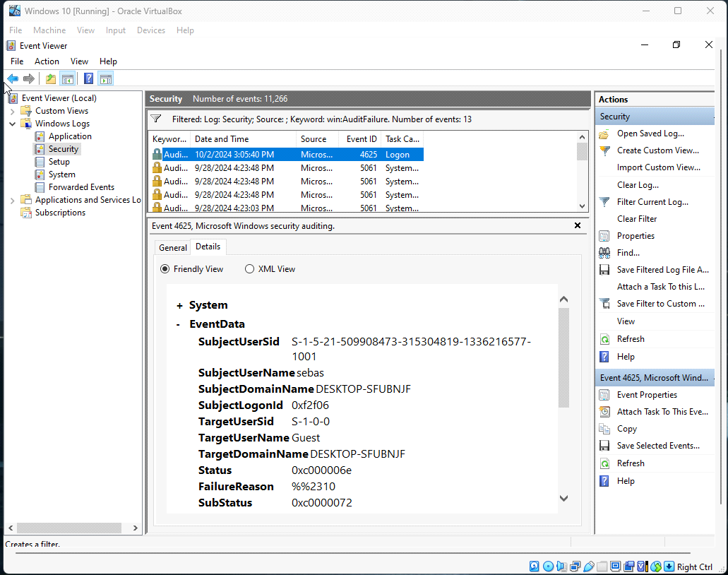

**4. Create a scheduled task that runs every hour and displays a random message in the command window:**

To begin, I accessed **Task Scheduler** by pressing **WIN + R** and entering the command **taskschd.msc**. In the **General** tab, I named the task **"Random Message"**. Then, in the **Triggers** tab, I clicked **New**

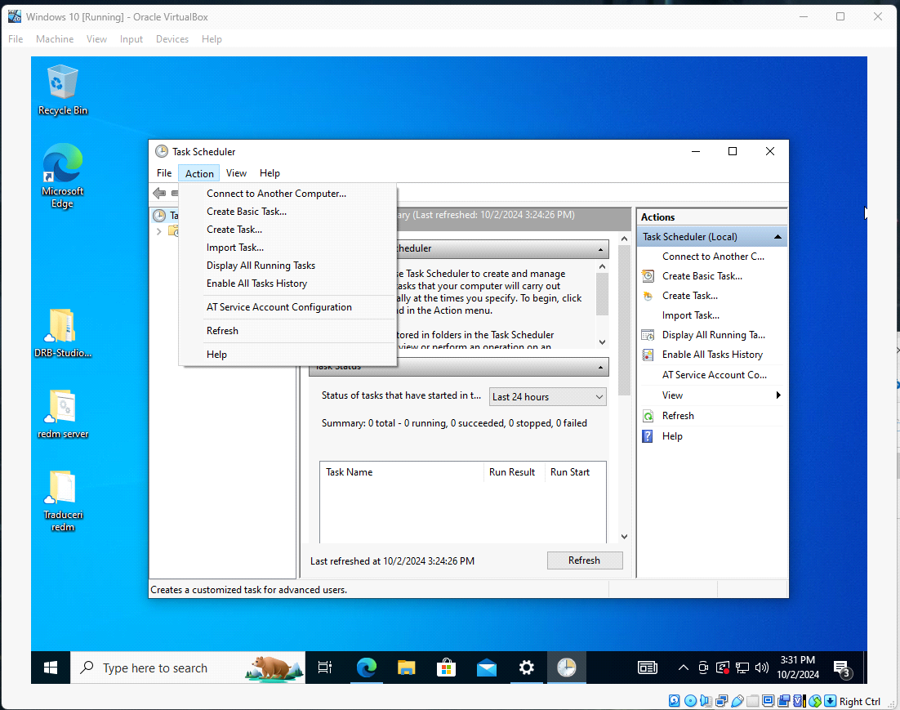

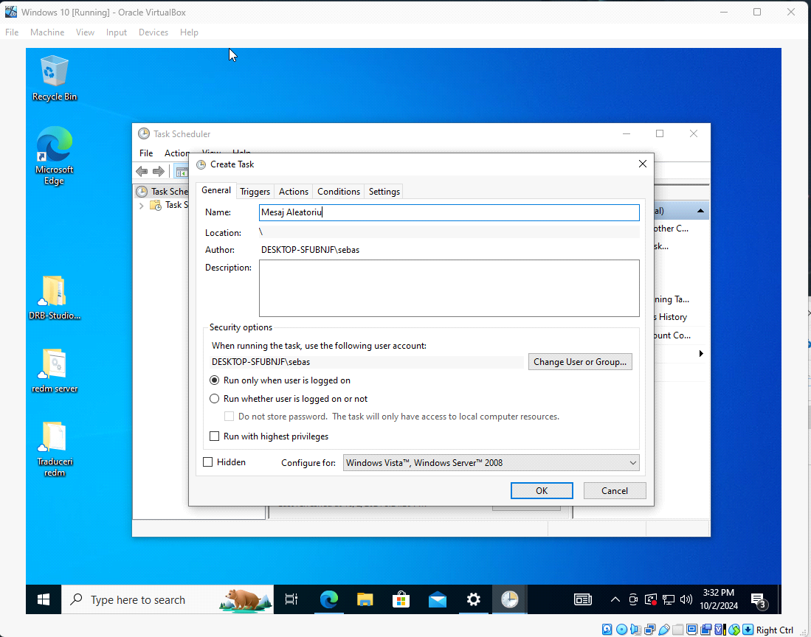

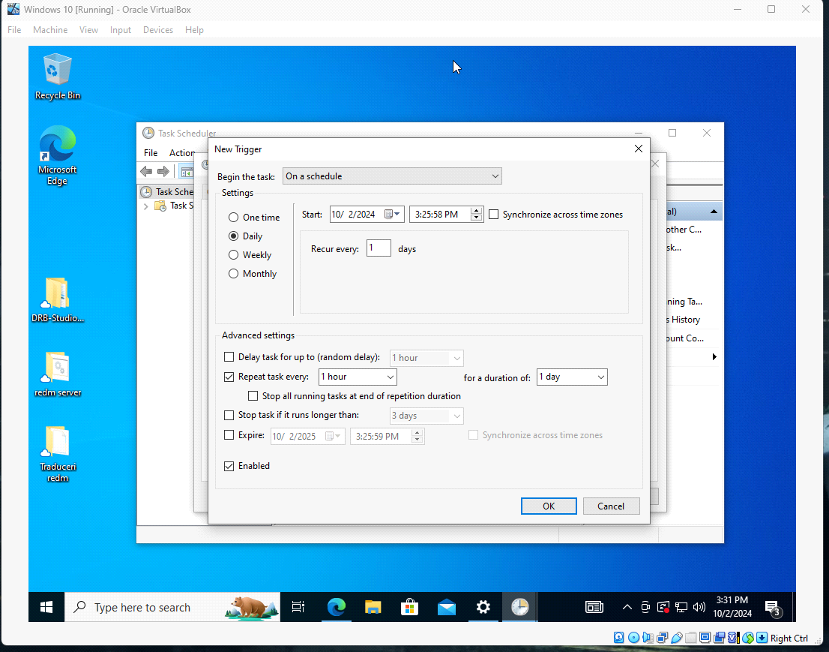

Then, I accessed the Actions tab, clicked on New, and selected Start Program. In the Program/Script field, I entered cmd.exe..